**Deploy the same application to Azure App Service. It should also leverage the database on the cloud**

# **Database Creation**

1. Go to portal.azure.com and login then search for the SQL databases and click on Create SQL database.

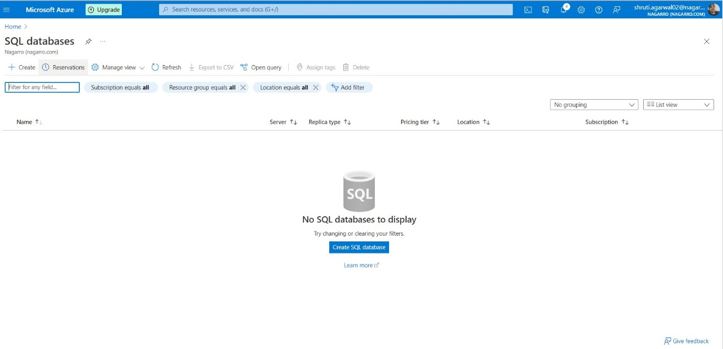

1. After clicking following screen will appear, then create server name and set a server admin user authentication credentials if want any

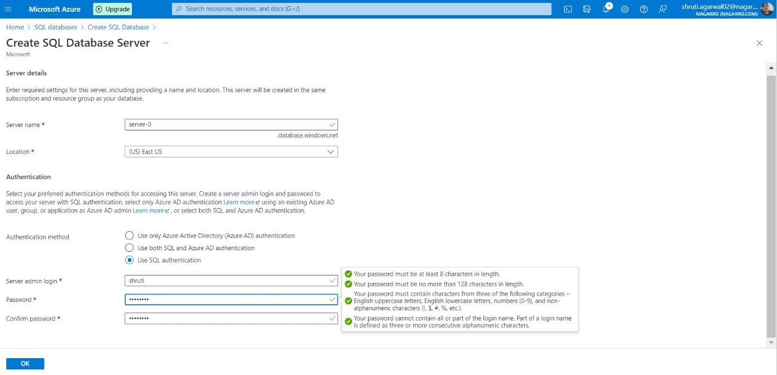

1. After setting up authentication credentials, then select your subscription, resource group(if not there then create new one).

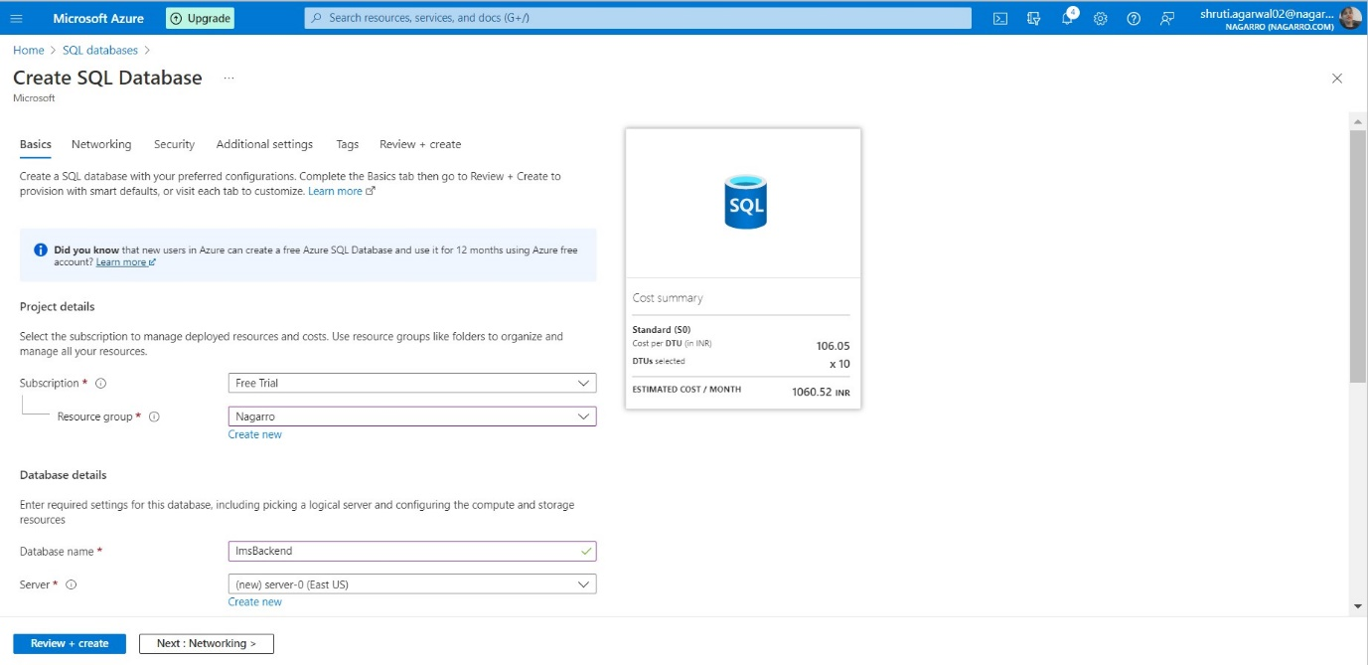

1. Give the name of the database and select your server (if not there create a new one)



1. Then select Public endpoint and scroll for further details

1. Then click on the Start free Trial option and click on Review and create

1. Click on Create button to create the database.

1. After creation of database following screen will appear the click on Go to resource button to see the database created

1. Click on Show database connection strings and get the required details to be used in the webapp.

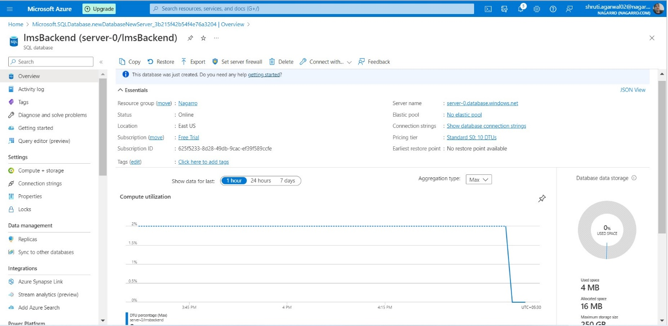

1. Setting up server firewall

1. Now, we can login to see the tables

1. Now, we can see the tables in query editor

**Deploying Application on App services**

1. Go to portal.azure.com and click on App services and then click on create app service.

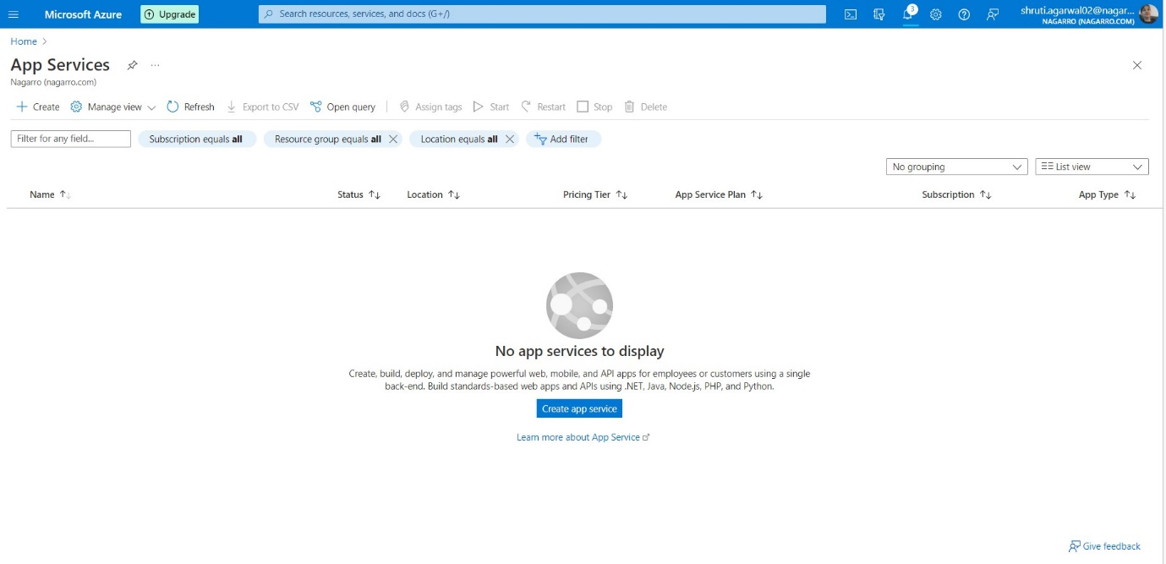

1. Select the Subscription and Resource group(if not there then create new one).

1. Then give the name to the application and select how you want to deploy the code. In my case I have selected Docker Container then select the operating system as Linux for docker and then select the region.

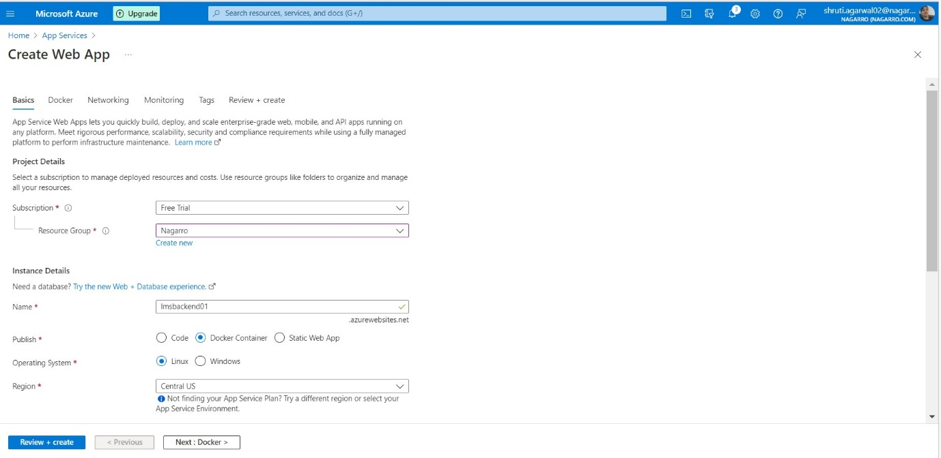

1. Select the 1GB memory option to get Free under the Pricing Plan section and click apply

1. Under the Image Source section select Docker Hub and click on review and create button.

1. Then click on Create button

1. After that wait for it to get deployed and then following screen will appear and then click on Go to resource

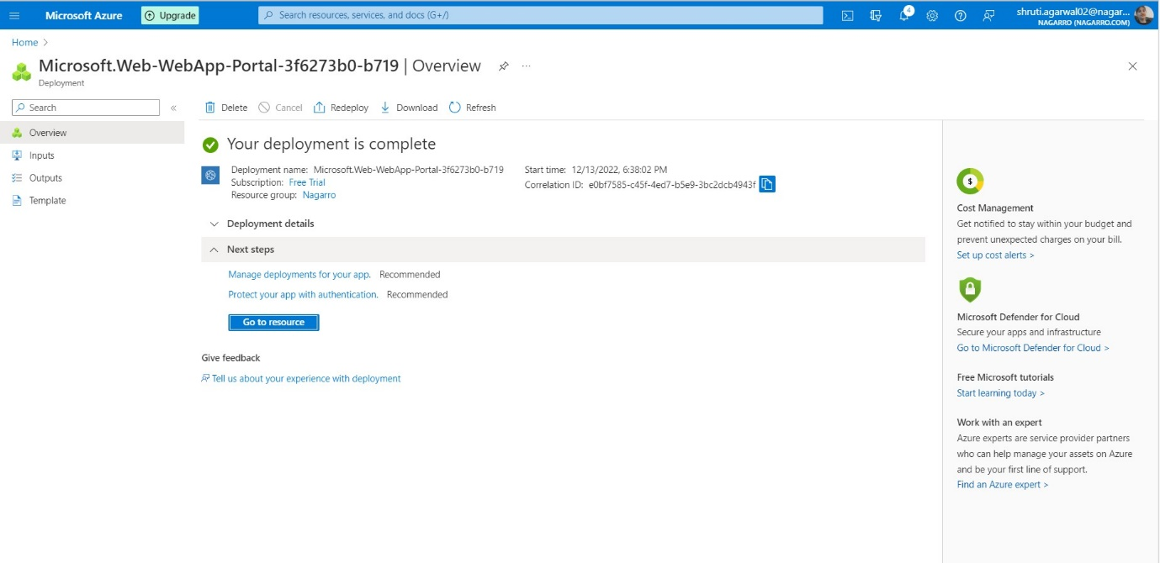

1. After that you will get the URL of the deployed app and you can access your application from this URL.

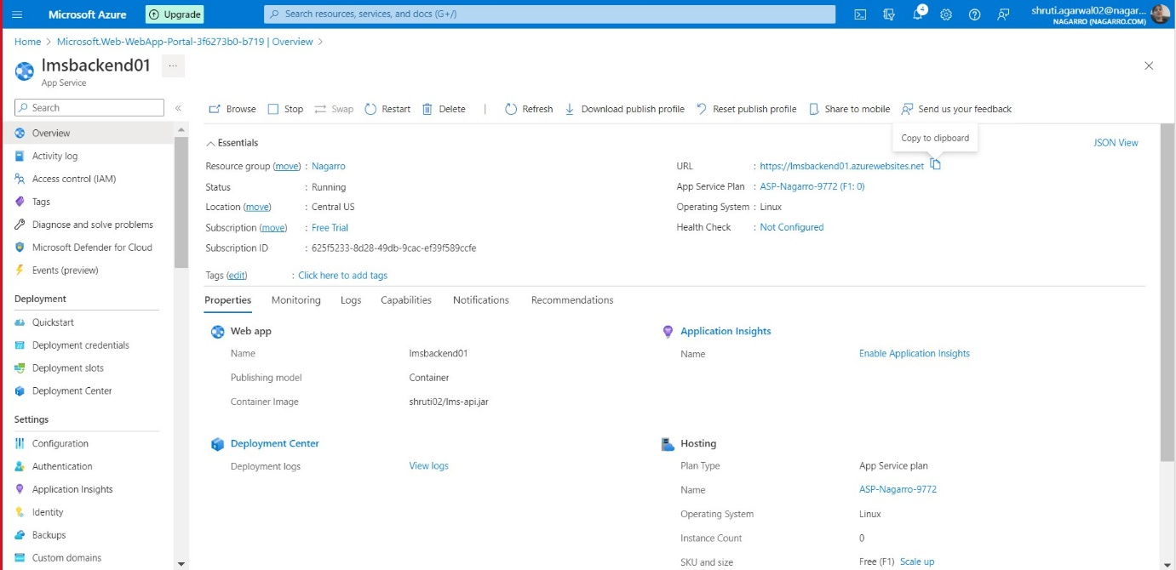

1. Screenshot of the result of the application accessed using the URL provided by azure app services

